There are many in market

JIRA – To write TC’S, Stories, to track their activity, log a defect, link defect to particular story, how to link TC to story, there is a life plugin is also available which can be integrated with jira to write TC’s and link to user stories

We can customize our company logo also.

Devops team and administration team, will take care of Jira, how to customize uploading & creating schema and everything, what kind of different customization need from project to project

Jira

Bugzilla – not using now,

HP/ALM

Test RALY – Defect Life Cycle and Test Case Documentation

* In single jira, it may be too many projects following different methodologies (eg: Agile – Sprint based system.) This all handle by the Administrator
* Single QA guy can work in different projects, project to project methodology varies, configuration varies.

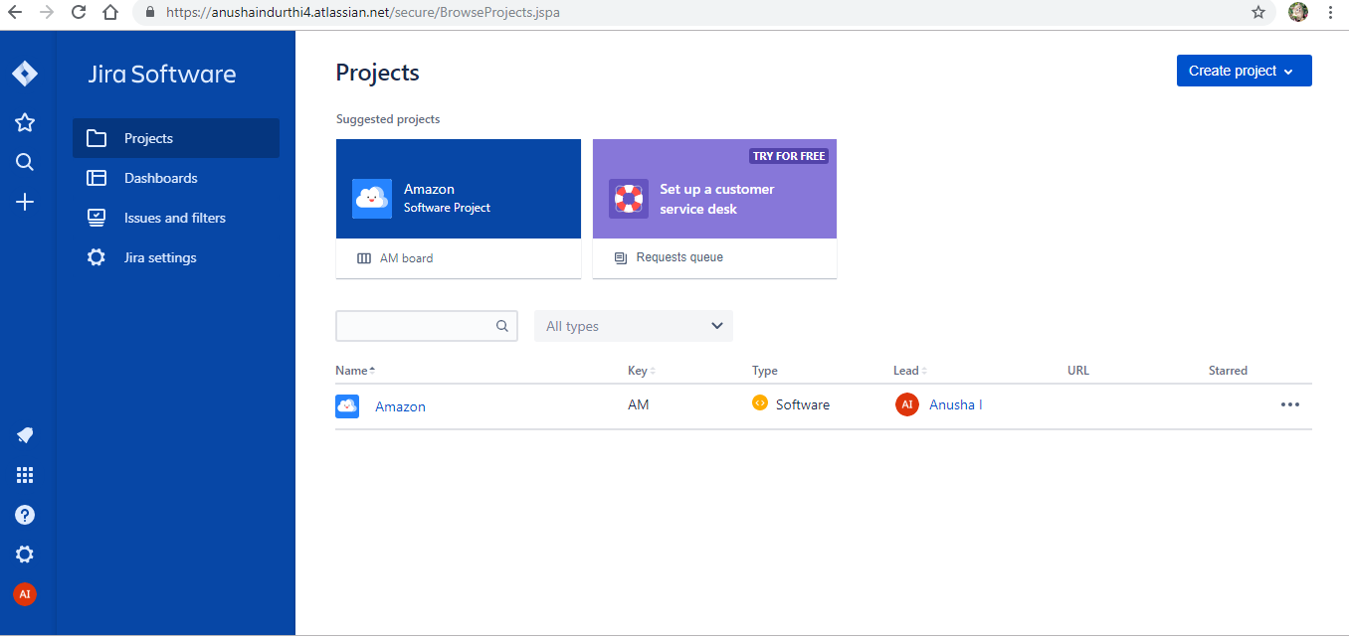

1. Click on your project , Here you will find like below

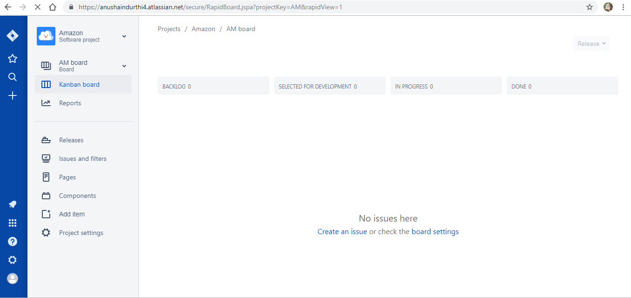

1. To create Story by product owner, click on ‘+’ symbol

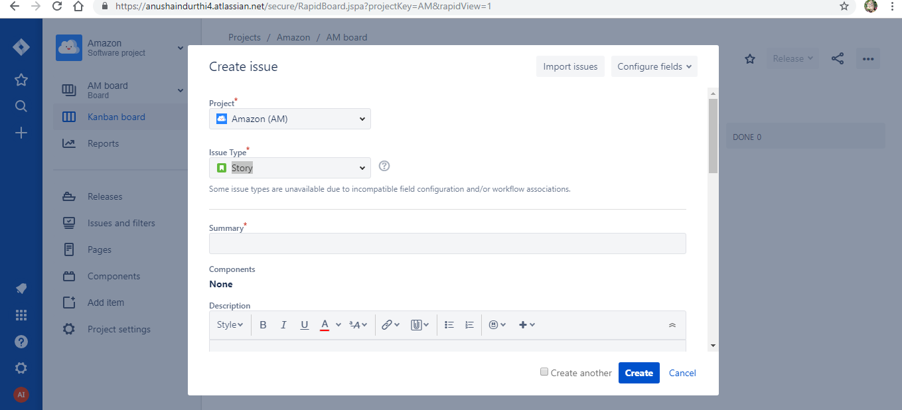

1. Here you will have

Project Name, Issue Type : (Story, Task, Bug, EPIC)

1. Story will created by Product Manager
2. Lets create EPIC

ORDER: These all are different issue types

->EPIC

->STORIES

->TASKS

->BUG

->TEST CASES

EPIC – is collection of multiple stories, or a complete system

Note: Epic can’t link to the other Epic